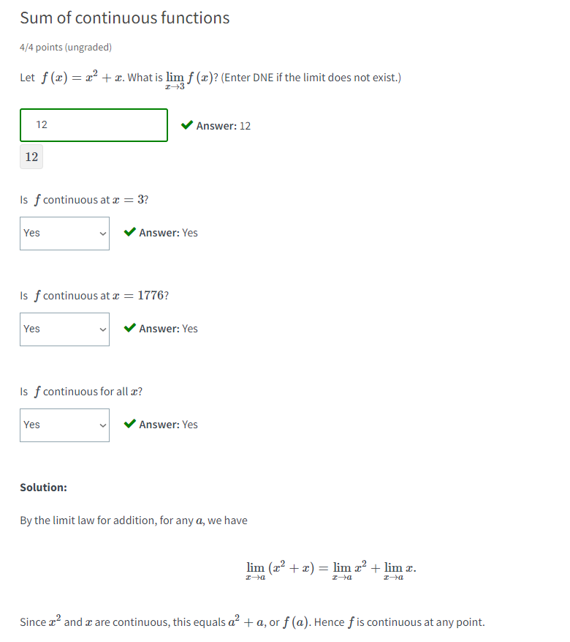

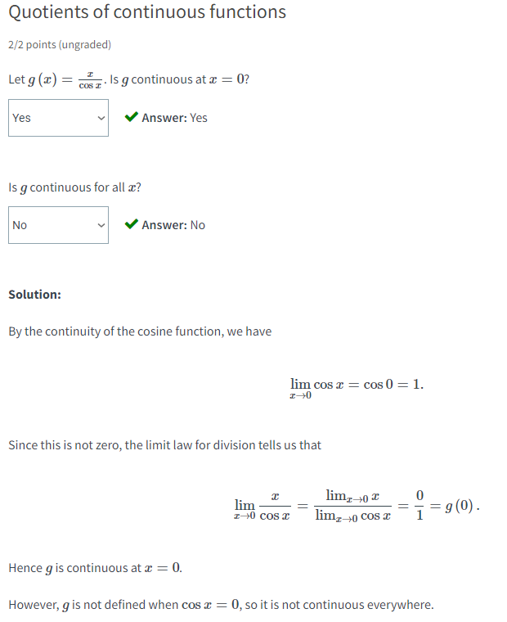

Limit laws and continuity

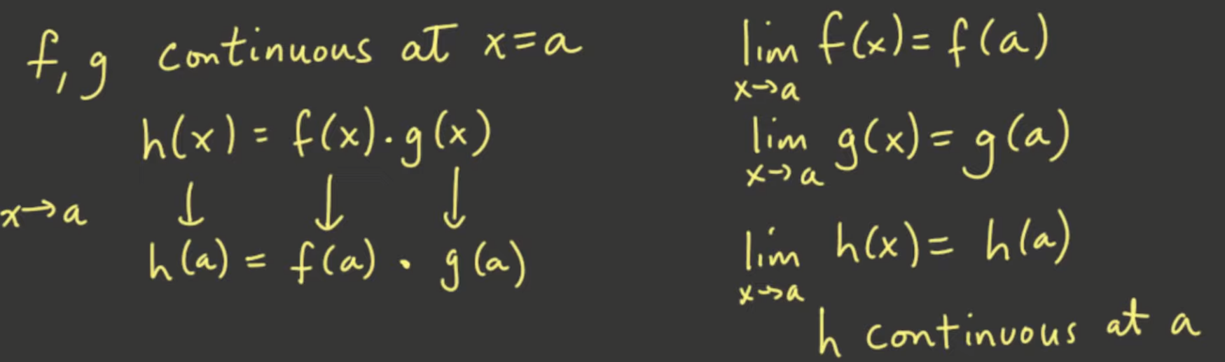



Applying these concepts of the limit laws: (addition, subtraction and multiplication)

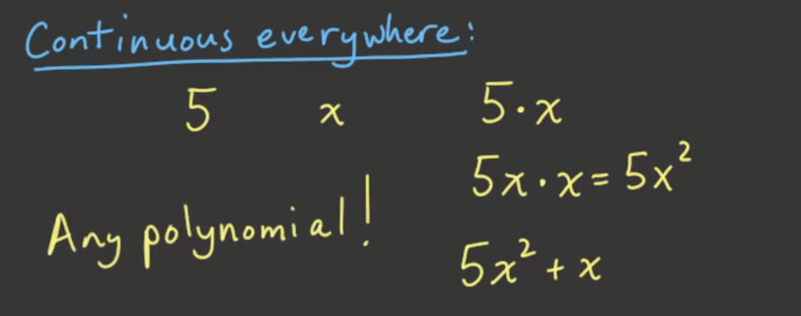

* If a constant is continuous everywhere and a single variable is continuous everywhere
  + Adding, multiplying, and subtracting it will result to continuity everywhere of the resulting function!
  + Basically any polynomial

For division:

* Continuous as long as the quotient is defined



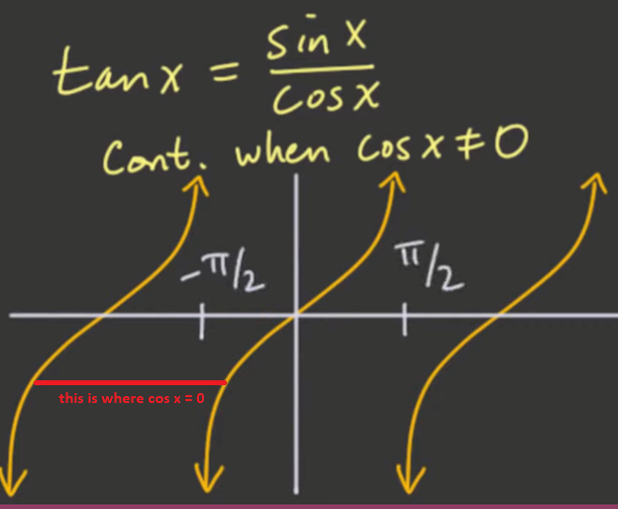

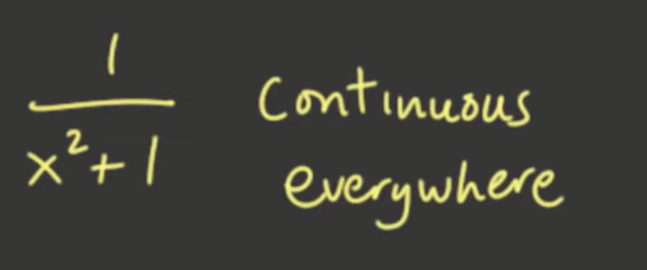

* Because its denominator will never be 0

Continuity of Composite Functions



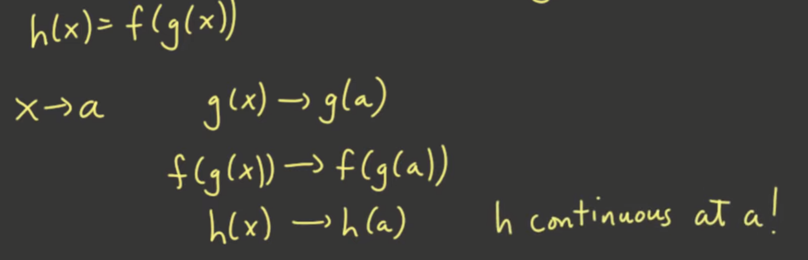

* As long as f and g are continuous everywhere

Example of composite functions that are continuous:

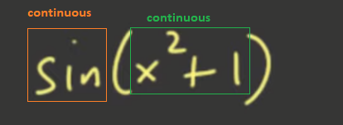

* Therefore: this is continuous!

Review:

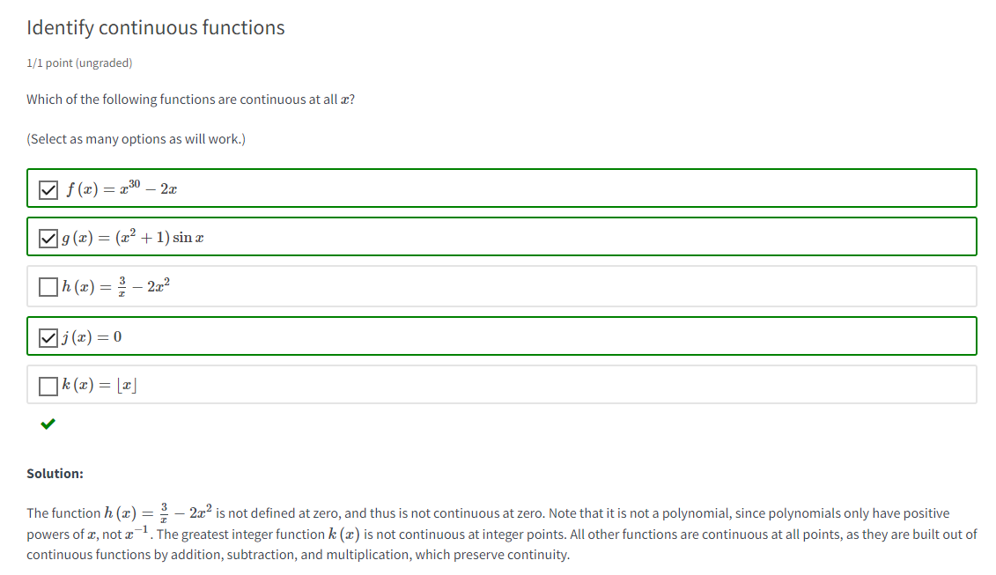

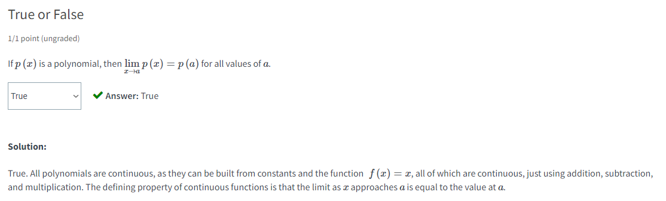

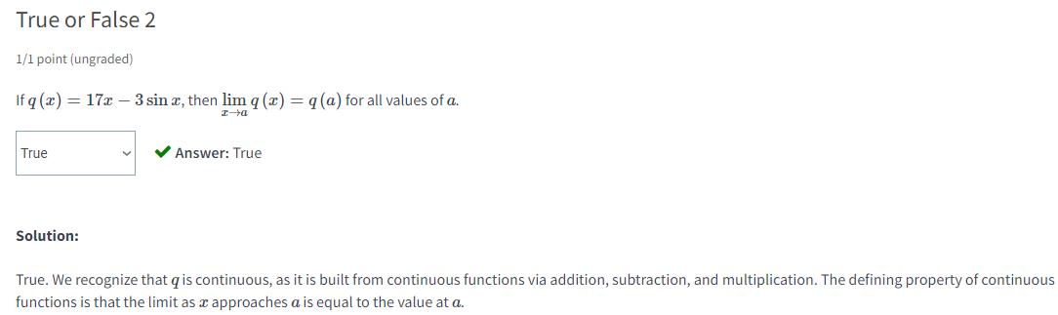

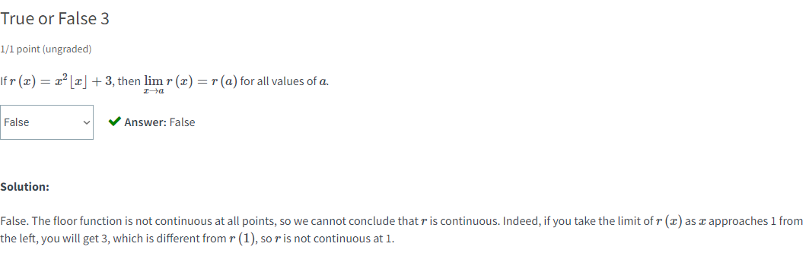

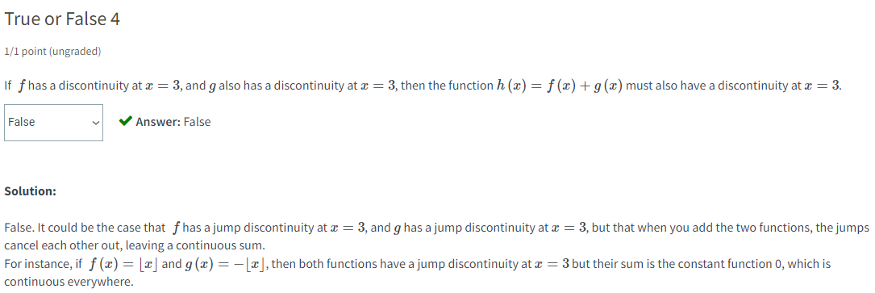

* Note: limit laws only applicable on CONTINUITY not DISCONTINUITY